SETTING UP ENVIRONMENT CREATE SENDGRID ACCOUNT

|  |  |
| --- | --- |
| Team ID | PNT2022TMID17805 |
| Project Name | Customer Care Registry |
| Team Members | Abishek L, Athista Laskhmi  Bala Murguan G, Harshini |

**Step 1:** Start the Sendgrid account creation by visiting https://sendgrid.com, to begin with registration.

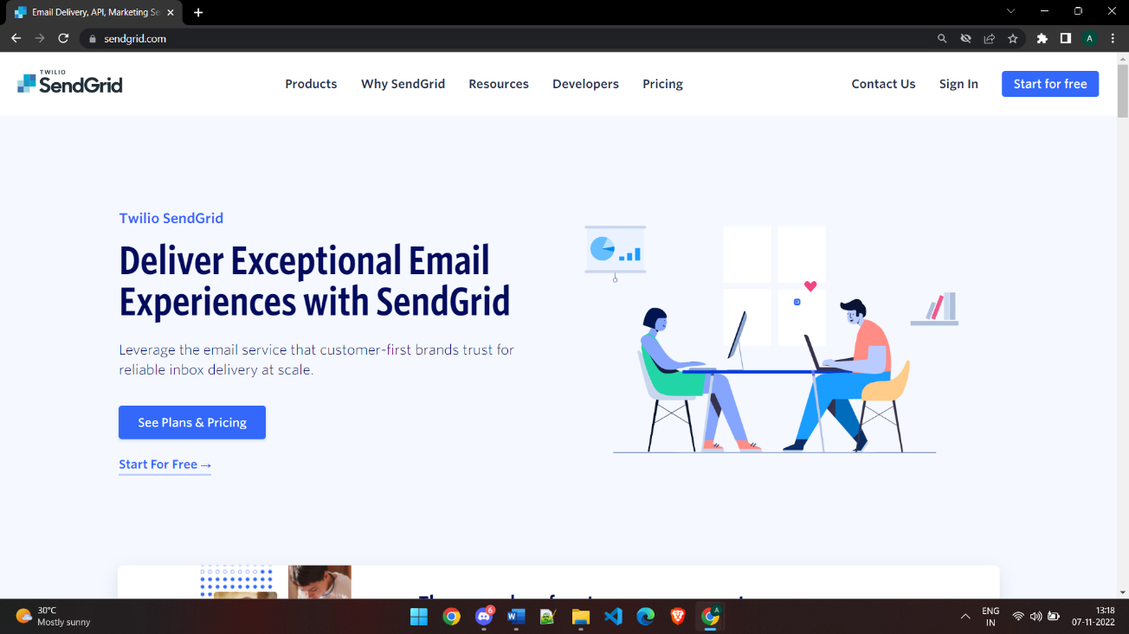

**Step 2:** Use the webmail credentials to register with the Sendgrid and fill in all the other details.

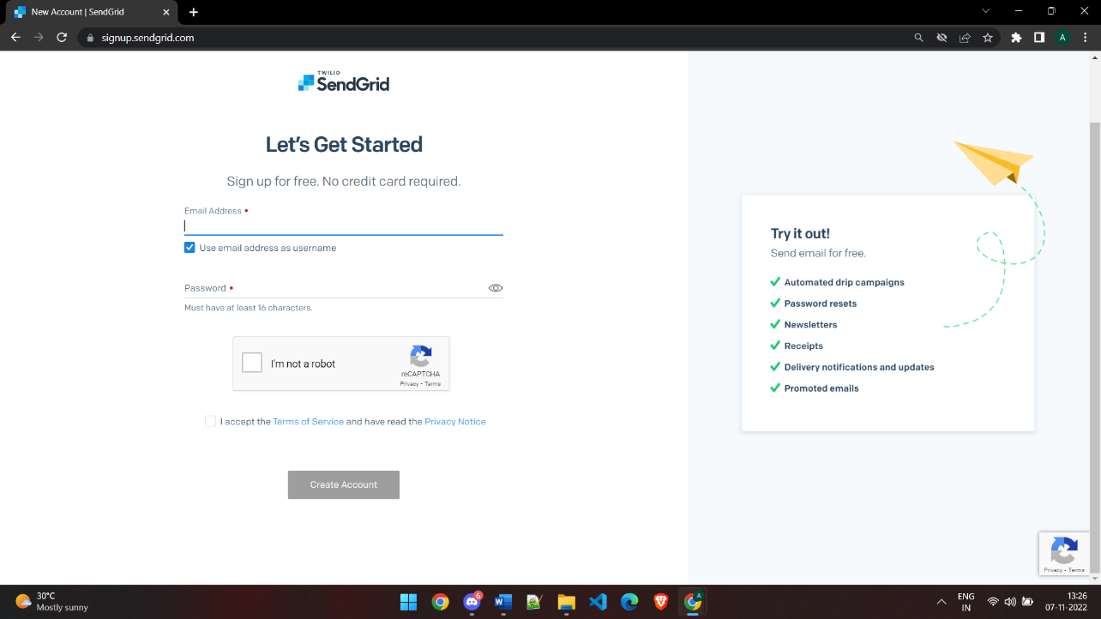

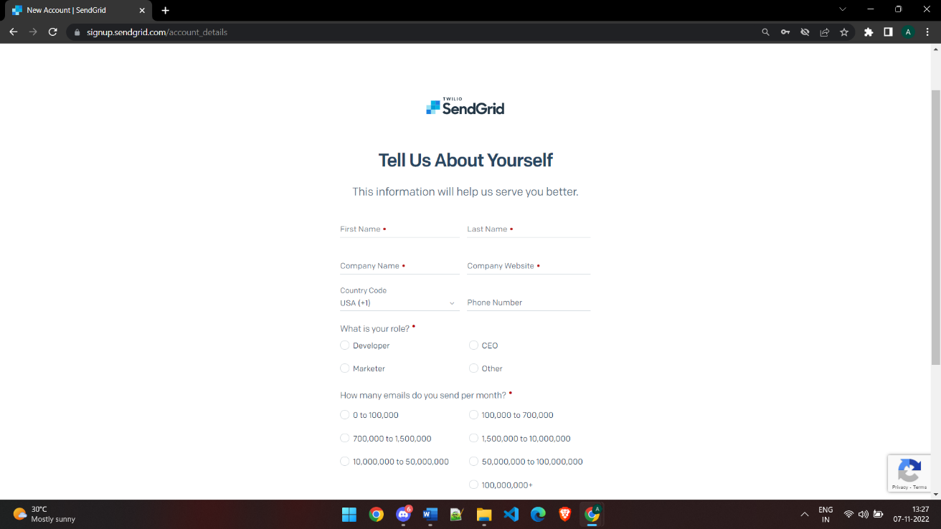

**Step 3:**Now after verifying IBM cloud account is created.

